Group 2: Mabel A, Dainty C, Matt E, JB K, and Radhika S

**New location of Mom’s Organic Market**

Link to primary Github: <https://github.com/MattEgan660/CompostLocator-.git>

History of Mom’s Organic Market: <https://momsorganicmarket.com/our-story/>

Dataset:

* Mom’s Store Locations, Google API
* Maryland Counties, <https://worldpopulationreview.com/us-counties/states/md> (file available as json or csv)
* Zip Codes by Population, <https://worldpopulationreview.com/zips> (file available as json or csv)
* Per capita personal income by county, <https://www.bea.gov/data/income-saving/personal-income-county-metro-and-other-areas> (csv)
* Demographics MD, <https://data.imap.maryland.gov/datasets/eb706b48117b43d482c63d02017fc3ff_1>(API/JSON)

Finding Inspiration: Mom’s Organic Market offers customers organic and locally grown produce, chemical- and preservative-free groceries, cruelty-free body care, and eco-household products.

We are marketing the idea of using a perspective store locator to assist with opening up a new location. This idea will be presented to the leaders of Mom’s Organic Market. We will convince the leaders of this organization using the various datasets above by creating an interactive map showing the area in need of a new location within Maryland.

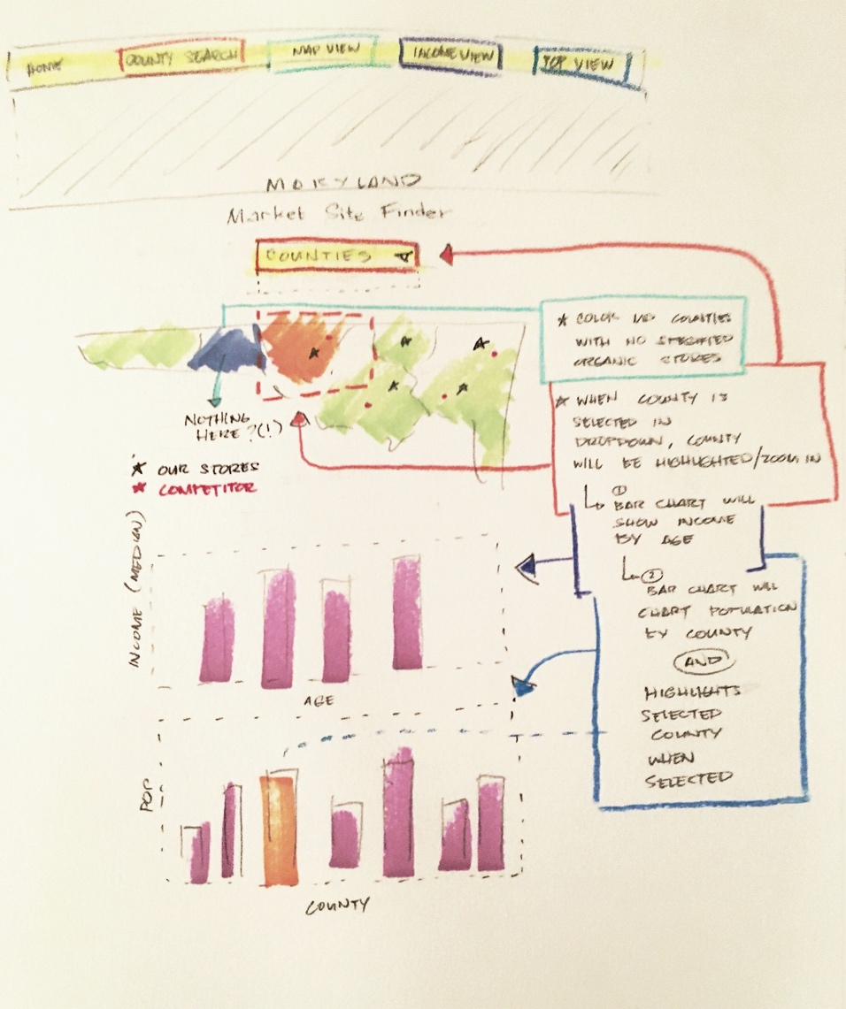Sketch of final design: